**Практика.  
Прочтите требования и проанализируйте их:**

**Settings/Functions on the “Create View” Page**

* “Report View Name” → sets Report View displayname for the roles: FirmManager and Advisor.
  + Text box
  + Character limit = 255
  + Validation: once user clicks outside of “Report View Name” textbox, validate displayname character count <= 256
    - If Fails validation, then display red border around text box
* Radio Icon “Report Type” component with options for Firm Report / Client Report → sets Report View viewcontext
* Radio Icon “Format” component with options for CSV / PDF/ XLS → sets Report View format
* Radio Icon “Orientation” component with options for Landscape/Portrait → sets Report View orientation
  + IF ReportView format = PDF, then show Orientation component only for FirmManager.
  + Else hide Orientation component
* Button: “Create View”
  + “Create View” is greyed out and not clickable unless:
    - displayname is not null
    - viewcontext is not null
    - format is not null
    - IF format = PDF, then orientation is null
  + Upon click, attempts to create and save Report View object
    - Save Validation: upon save, validate that displayname must be unique within firm
      * If Fails validation, then display red border around text box and prevent save
    - Save Validation: upon save, validate that displayname character count <=255
      * If Fails validation, then display red border around text box and display message:
  + Upon successful save by clicking Save button, takes you to Report Builder Page.

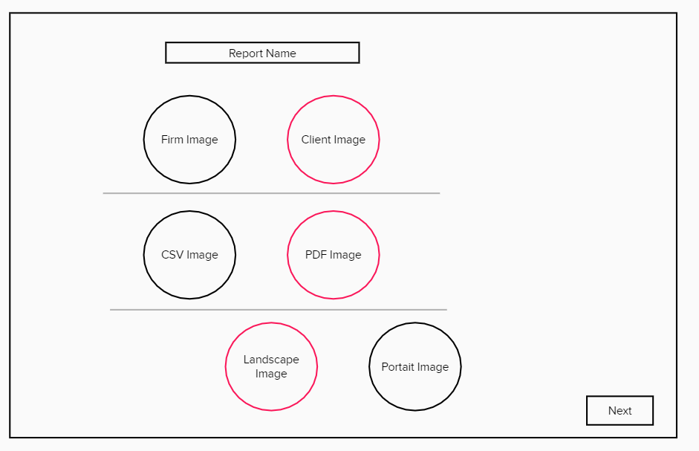  
  
  
**Это был пример пользовательских требований к New Feature.**

**А теперь Задания:**  
1. Найдите ошибки в требованиях и нестыковки с дизайном.

2. Напишите минимум 3 User stories, исходя из представленных требований, опираясь на следующий формат:  
**Как, <роль/персонаж юзера>, я <что-то хочу получить>, <с такой-то целью> .**

**Пример: As a FirmManager I want to open “Create View” Page, click on “Report View Name” field, so that I can input text in it.**

1. FirmManager and Advisor, sets Report View displayname for the roles, Settings/Functions on the “Create View” Page
2. Radio Icon “Report Type” component with options for Firm Report / Client Report → sets Report View viewcontext
3. Radio Icon “Format” component with options for CSV / PDF/ XLS → sets Report View format
4. Radio Icon “Orientation” component with options for Landscape/Portrait → sets Report View orientation

**Формат сдачи ДЗ свободный, без шаблона. Загрузите доки в github, ссылки на github скидывайте прямо в чат (только проследите, что вы даете доступ к просмотру вашего документа).  
Дедлайн(Deadline): 23:59 pm 4 октября ВТ.**

**Repositories: QAM10   
File naming: Meaningful part + (hw_1). Example “Requirements Analysis(hw_1)”**